**Project Initialization and Planning Phase**

| Date | 07 july 2024 |
| --- | --- |
| Team ID | SWTID1720084639 |
| Project Name | **Beneath The Waves: Unraveling Coral Mysteries Through Deep Learning** |
| Maximum Marks | 3 Marks |

**Define Problem Statements (Customer Problem Statement Template):**

Coral reefs are vital marine ecosystems facing rapid decline. Manual analysis of underwater imagery for coral health assessment is slow, expensive, and requires expertise, limiting large-scale monitoring. This project aims to develop a deep learning-based solution to **automate coral reef analysis**, enabling researchers and conservationists to efficiently assess reef health, identify coral species, and track threats, ultimately contributing to more effective conservation strategies.

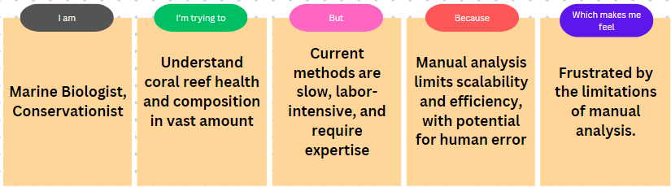

|  |  |  |  |  |  |
| --- | --- | --- | --- | --- | --- |
| **Problem**  **Statement (PS)** | **I am**  **(Customer)** | **I’m trying to** | **But** | **Because** | **Which makes me feel** |
| PS-1 | Marine Biologist, Conservationist.Understand the health and composition of coral reefs. | Analyze vast amounts of underwater imagery to identify coral species, track reef health, and monitor threats. | Current methods are time-consuming, labor-intensive, and require expert knowledge. | Manual analysis involves tedious image classification and limited scalability for large datasets. | Frustrated by the inefficiency and potential for human error in manual analysis. |